Create Database system for E-commerce Website management - 40Marks

1. Create minimum 5 tables without any Key constraints(5)

**Create table CUSTOMERS(**

**CID int,**

**Cname varchar(100),**

**CADDR VARCHAR(150),**

**CMOB int**

**);**

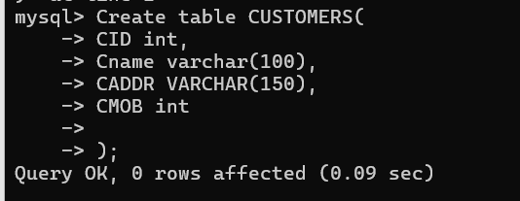

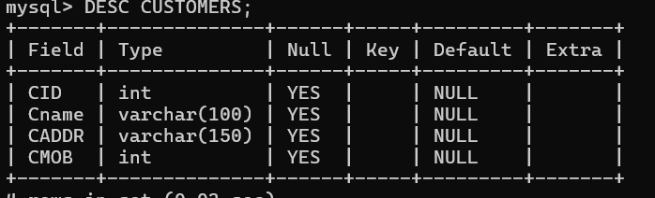

**Create table ORDERS(**

**OID int,**

**ODATE DATE,**

**DELYDATE DATE,**

**CID int**

**);**

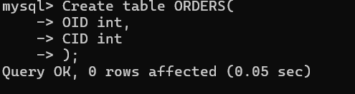

**Create table PRODUCTS(**

**PID int,**

**PNAME varchar(100),**

**RATE INT**

**);**

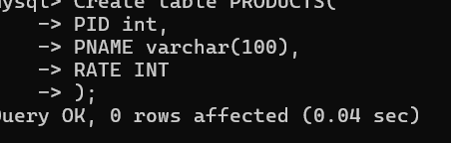 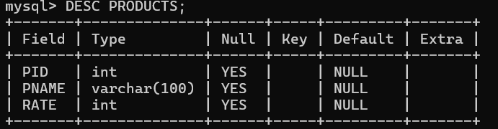

**Create table DETAILS(**

**OID int,**

**PID INT,**

**QTY INT**

**);**

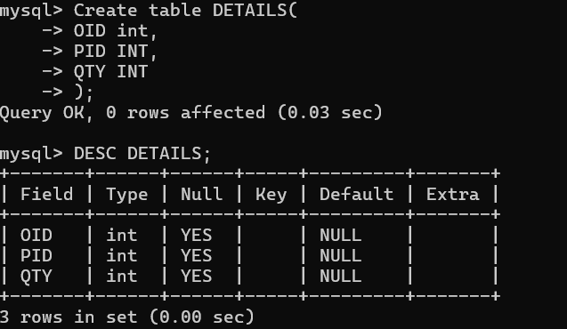

**Create table PURCHASE(**

**Cno int,**

**Cname varchar(100),**

**PURID INT,**

**PNAME varchar(100),**

**RATE INT,**

**TOTAL INT**

**);**

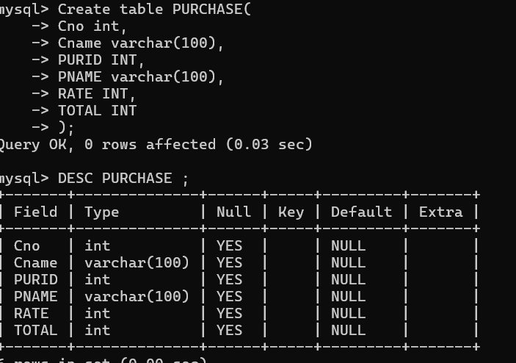

2. Add Primary Key to each table(3.5)

MODIFY

3. Connect atleast 3 tables using Foreign Key(2)

FOREIGN KEY (CID) REFERENCES CUSTOMERS(CID);

FOREIGN KEY (PID) REFERENCES PRODUCTS(PID);

FOREIGN KEY (OID) REFERENCES ORDERS(OID);

4. Insert minimum five records in each of the table(3.5)

INSERT INTO **CUSTOMERS( CID ,Cname ,CADDR , CMOB ) VALUES (1, ‘SHUBHRA’, ‘BHOPAL’,123),(2, ‘JYOTSNA’, ‘MP’, 456),(3, ‘SJM’, ‘DEL’, 789),(4, ‘PUSHPITA’, ‘BNGL’,777),(5, ‘PULKIT’, ‘PUNE’,555));**

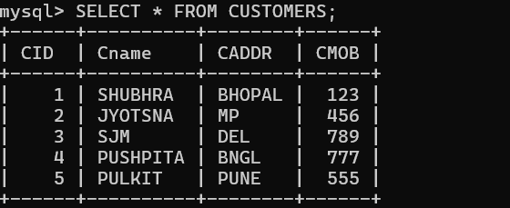

**INSERT INTO ORDERS**

**INSERT INTO PRODUCTS(PID , PNAME ,RATE INT) VALUES();**

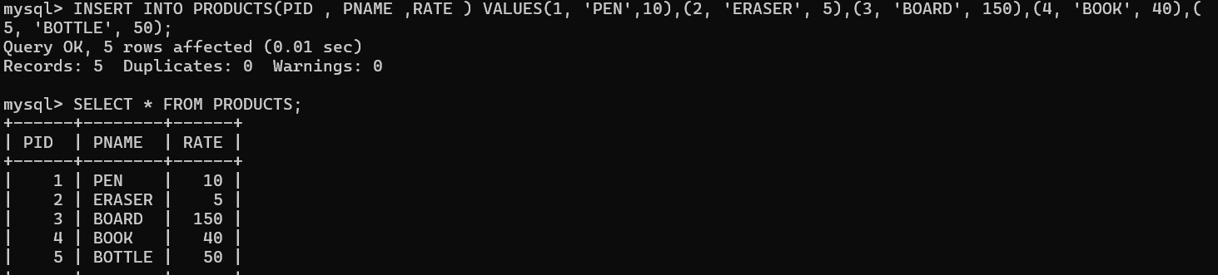

**INSERT INTO DETAILS**

**INSERT INTO PURCHASE**

5. Write an appropriate command to Use of Where with OR clause (2)

SELECT CNAME FROM CUSTOMERS WHERE CID=1 OR CID=2;

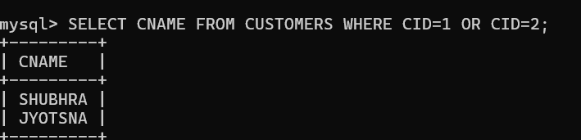

6. Write a command to show first five records from any one table (2)

SELECT * FROM CUSTOMERS LIMIT 5;

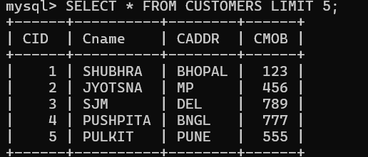

7. Write a command for appropriate and logical use of Group By clause(2)

**SELECT CNAME, CADDR FROM CUSTOMERS GROUP BY CADDR;**

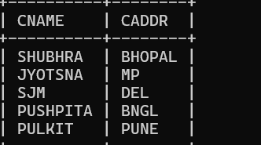

8. Write a query to show the name of 2nd costliest product along with its cost(2)

SELECT PNAME ,RATE FROM PRODUCTS ORDER BY RATE DESC OFFSET 1;

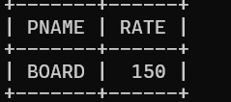

9. Create ONE simple view using any of the created table and update the data from view to

reflect in base table (2)

CREATE VIEW CUSTOMERS_VIEW AS

SELECT CID, CNAME, CADDR FROM CUSTOMERS;

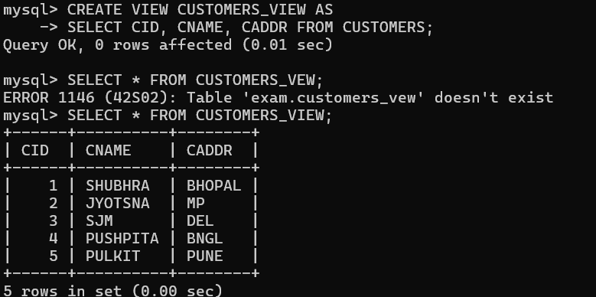

10. Write a command to use LEFT JOIN (2)

SELECT CNAME FROM CUSTOMERS

LEFT JOIN ORDERS ON CUSTOMERS.CID= ORDERS.CID;

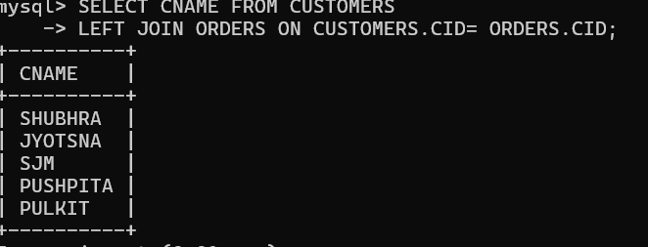

11. Create the temporary table showing only Electronic items. How to remove this table

permnantly? (2)

CREATE TEMPORARY TABLE TEMPP(

ELECTRONICS VARCHAR(20)

);

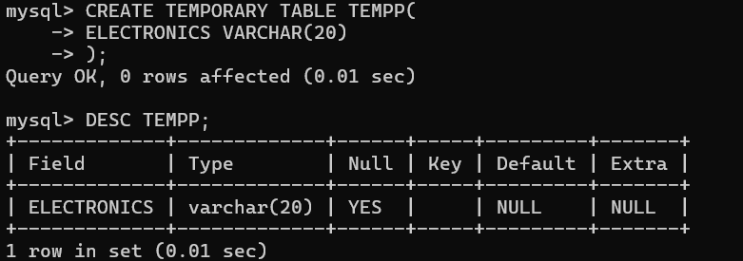

DROP TEMPORARY TABLE TEMPP;

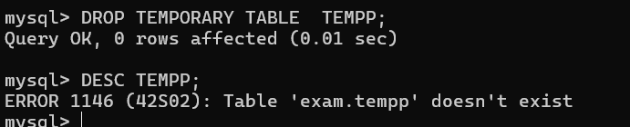

12. Create at least one procedure (with one INPUT and one OUTPUT parameter) based on

the created tables with appropriate utility (4)

CREATE TABLE TEMPP(

FIR VARCHAR(20),

SET INT

)

DELIMITER//

CREATE PROCEDURE ABC()

DECLARE X INT DEFAULT 10;

DECLARE Y INT

BEGIN

INSERT INTO TEMPP VALUES(X,Y)

END

DELIMITER;

CALL ABC();

SELECT * FROM TEMPP;

13. Write a program to display first 5 even numbers using any one of the looping structure of

MySQL(4)

14. Create a stored function name DISC_CALC that takes two parameters:-

ORIGINAL_PRICE and DISCOUNT_PERCENTAGE. The function should calculate the

discounted price based on the original price and the discount percentage. The function

should return the discounted price.(4)

DELIMITER//

CREATE FUNCTION DISC_CALC ()

BEGIN

DECLARE ORIGINAL_PRICE INT

DECLARE DISCOUNT_PERCENTAGE

END

DELIMITER;

DELIMITER//

CREATE PROCEDURE ABC()

BEGIN

END

DELIMITER;